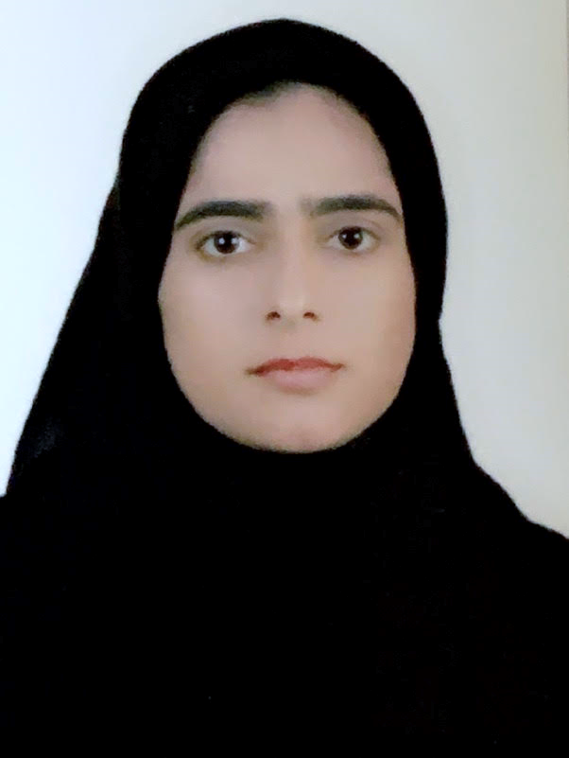

**Name:** Jawahir hafizallah habib waleed mohammed

**ID Number:** 870209191

**Date of Birth:** 01/Febuary,1987

**Tel: 35052585 / 39158645**

**Address :** House No 2071 Road 2728 Block 927 Riffa

**Email:** [jowahir-87@hotmail.com](mailto:jowahir-87@hotmail.com)

**EDUCATION**

* 2017 B.Cs. in Marketing-Management ,University of Bahrain
* 2013 Diploma in Commercial studies, University of Bahrain
* 2006 Secondary School Certificate in Commercial, Maarafa Secondary School

**EXPERIENCE**

* Jul 2019 Training General English at Kalimat Training Center.
* Sep 2018 Work volunteer at East Riffa Health Center.
* Jan 2013 Training at Personnel Department.

**SKILLS**

* Using The Computer (Managing files, Word, excel, access, PowerPoint)
* Internet, Outlook
* Typing Arabic, English
* Time Management
* A good team work
* Work Under Pressure

**LANGUAGES**

* Arabic Native spoken, written
* English Good spoken, written

**HOBBIES AND INTERESTS**

* Work volunteer
* Sports